Gitflow Workflow

What is Gitflow Workflow?
# Source: AI Source: Provided by: [Data Path: Persons Table -> ID Column: 1, Name_En Column: Motasem Essam] -> From: [ChatGPT] on [2/15/2026]
Gitflow Workflow is a structured Git branching model that defines strict rules for how branches are created, merged, and maintained during development and release cycles.
It was introduced by Vincent Driessen to organize software development and release management in a clear and scalable way.
Gitflow is designed for projects that have scheduled releases and need strong control over production stability.

Main Branches in Gitflow
# Source: AI Source: Provided by: [Data Path: Persons Table -> ID Column: 1, Name_En Column: Motasem Essam] -> From: [ChatGPT] on [2/15/2026]
Gitflow uses two permanent branches:
- main
  - Contains production-ready code
  - Every commit represents a release
- develop
  - Contains the latest development changes
  - Acts as the integration branch for features

Supporting Branches
# Source: AI Source: Provided by: [Data Path: Persons Table -> ID Column: 1, Name_En Column: Motasem Essam] -> From: [ChatGPT] on [2/15/2026]
Gitflow also defines temporary branches:
- feature branches
Created from develop
Used to develop new features
Merged back into develop
- release branches
Created from develop
Used to prepare a new production release
Merged into both main and develop
- hotfix branches
Created from main
Used to quickly fix production bugs
Merged into both main and develop

Conceptual Visualization
# Source: AI Source: Provided by: [Data Path: Persons Table -> ID Column: 1, Name_En Column: Motasem Essam] -> From: [ChatGPT] on [2/15/2026]
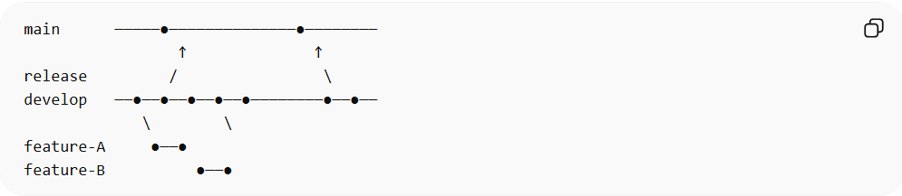
main ─────●──────────────●────────
↑ ↑
release / \
develop ──●──●──●──●──●────────●──●──
\ \
feature-A ●──●
feature-B ●──●

When It Is Used
# Source: AI Source: Provided by: [Data Path: Persons Table -> ID Column: 1, Name_En Column: Motasem Essam] -> From: [ChatGPT] on [2/15/2026]
- Large projects
- Enterprise systems
- Applications with scheduled releases
- Teams needing strict release management

Advantages
# Source: AI Source: Provided by: [Data Path: Persons Table -> ID Column: 1, Name_En Column: Motasem Essam] -> From: [ChatGPT] on [2/15/2026]
- Clear structure and role for each branch
- Strong control over releases
- Separates development and production clearly
- Good for versioned software products

Disadvantages
# Source: AI Source: Provided by: [Data Path: Persons Table -> ID Column: 1, Name_En Column: Motasem Essam] -> From: [ChatGPT] on [2/15/2026]
- More complex than other workflows
- Requires strong team discipline
- Can feel heavy for small or fast-moving projects
- Not ideal for continuous deployment environments

Key Idea (Exam Summary)
# Source: AI Source: Provided by: [Data Path: Persons Table -> ID Column: 1, Name_En Column: Motasem Essam] -> From: [ChatGPT] on [2/15/2026]
Gitflow Workflow = Structured branching model with main, develop, feature, release, and hotfix branches.
It provides strong release management but adds complexity compared to simpler workflows like Centralized or Feature Branch.

